Assinment-8

Read Data From CSV File

Using.reader()

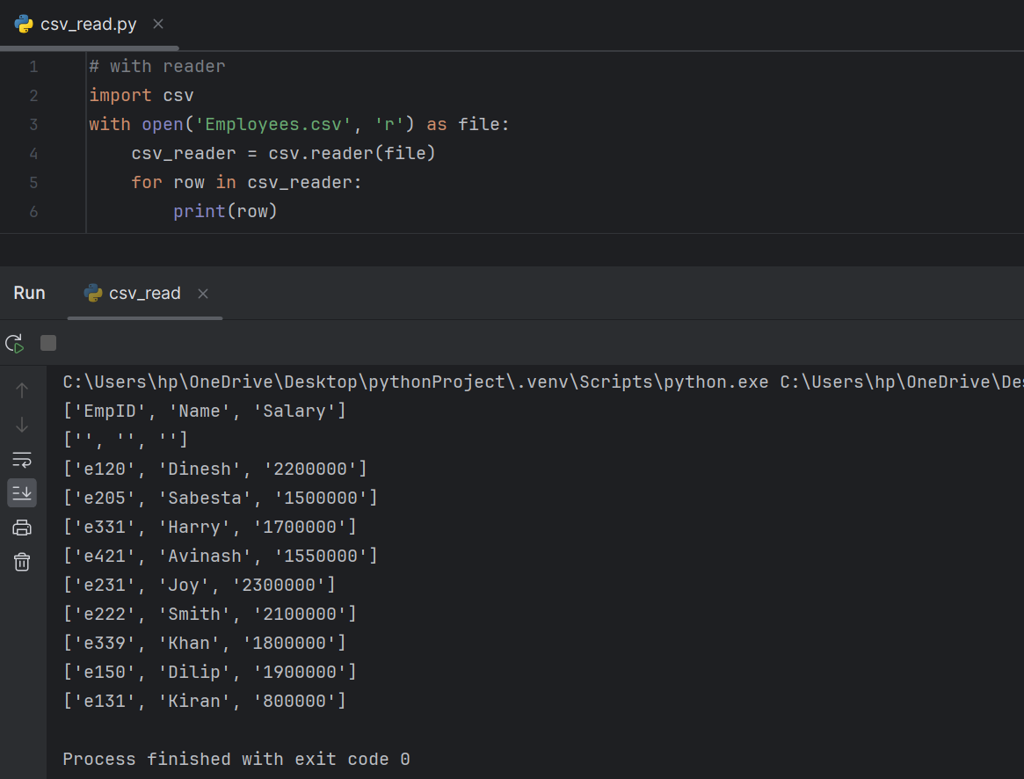

Using.Pandas()

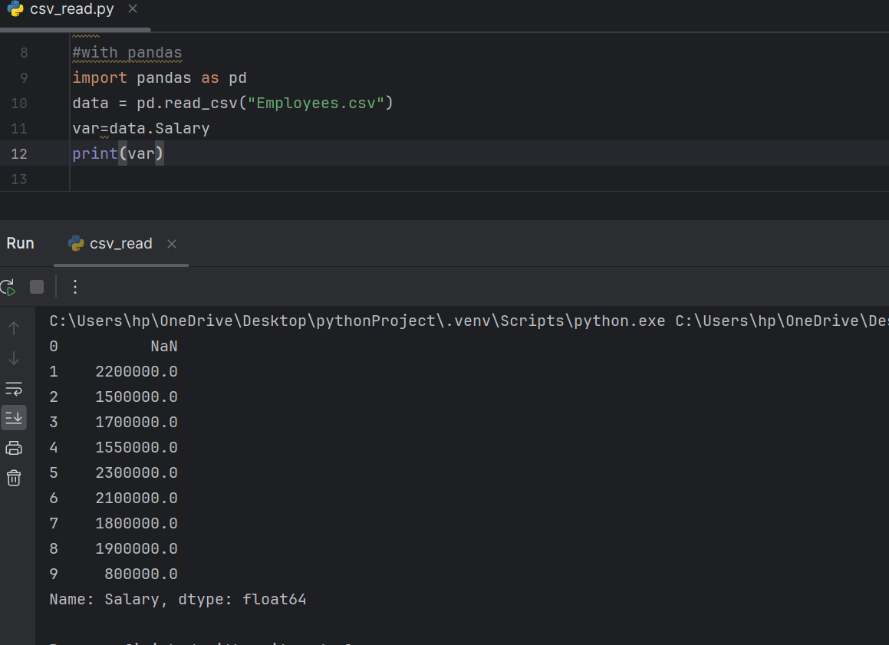

Using.dictreader()

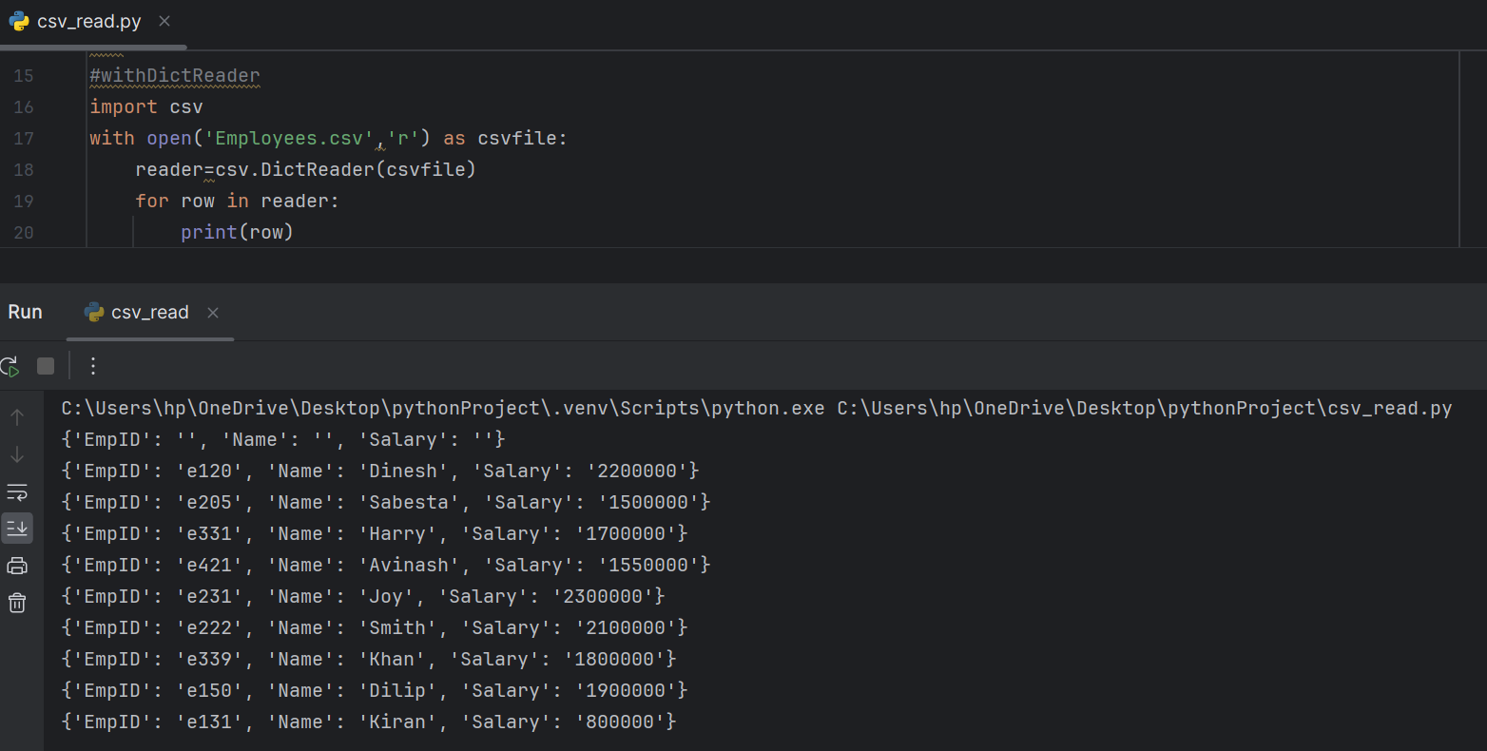

Using.readlines()

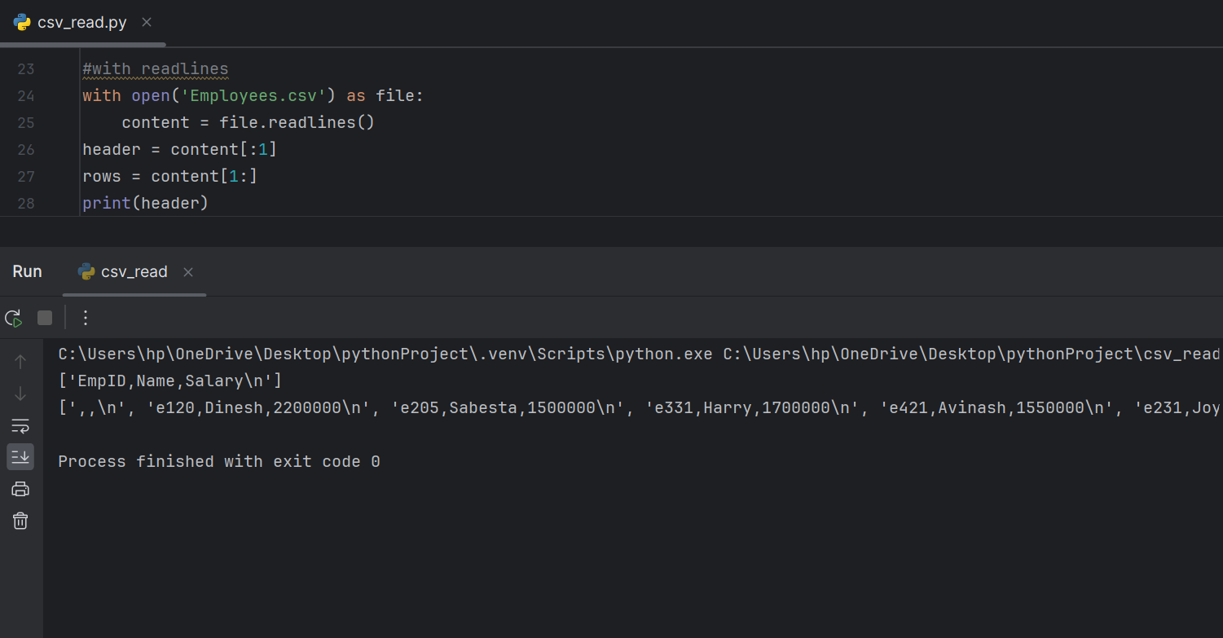

**Lambda And Filter**

Lambda functions are also known as anonymous functions, inline functions, or lambda expressions. The syntax for a lambda function is generally more concise compared to regular function definitions.

This function can have any no arguments but only one expression which is evaluated and returned.

**Use of Lambda and Filter:**

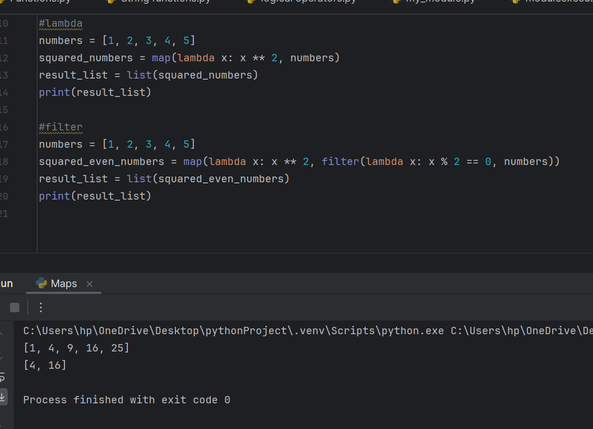

Lambda with reduce:

